**Twitter Sharing**

**Twitter App:**

Create Twitter App to use Twitter features like: status or tweets.

**Steps:**

1. Create Twitter Application here: <https://developer.twitter.com/en/portal/projects-and-apps> with following settings:

E.g.:

Name => SocialSharingUsome

App permissions => Read & Write

Authentication settings => 3-legged OAuth is enabled

CALLBACK URLS => <https://localhost:44300/Home/SocialSharing> (Live Url for Prod)

WEBSITE URL => <http://gmail.com/> (Live Url for Prod)

TERMS OF SERVICE => <http://gmail.com/> (Live Url for Prod)

PRIVACY POLICY => <http://gmail.com/> (Live Url for Prod)

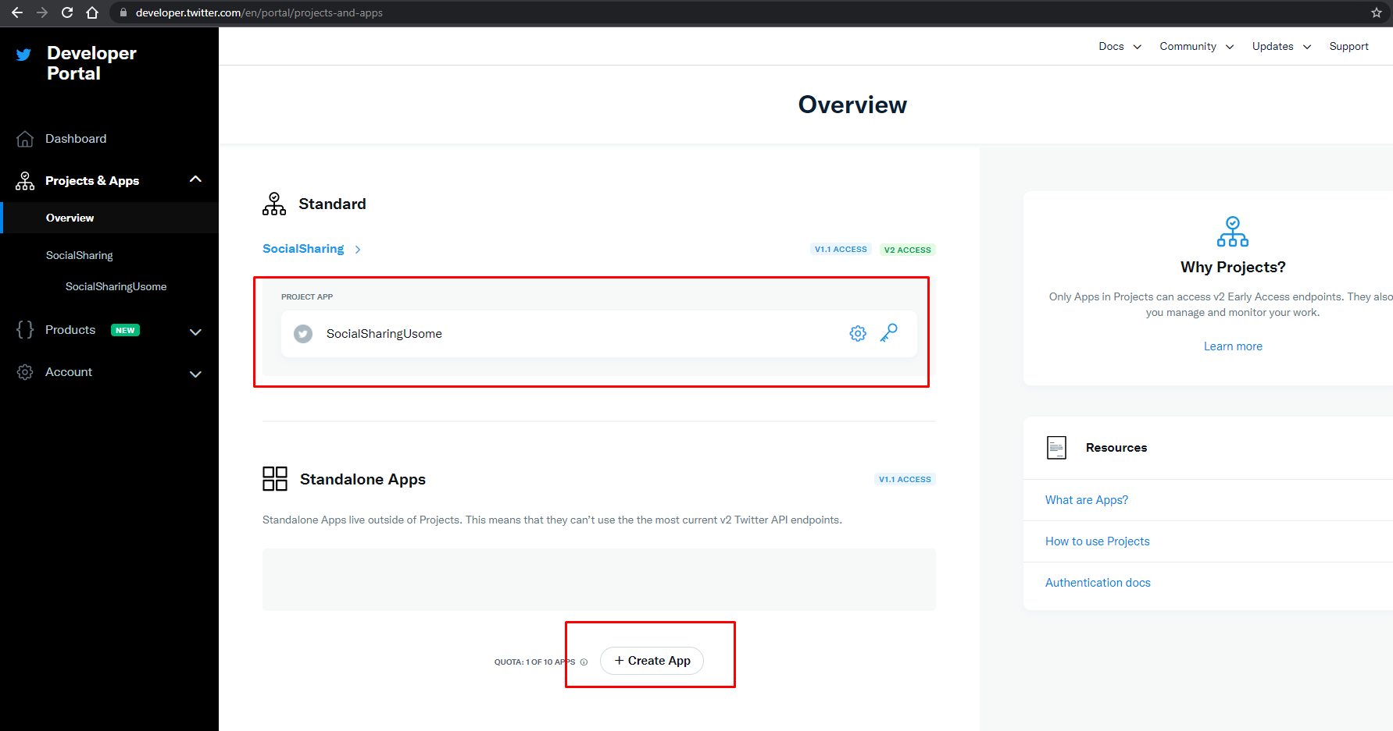

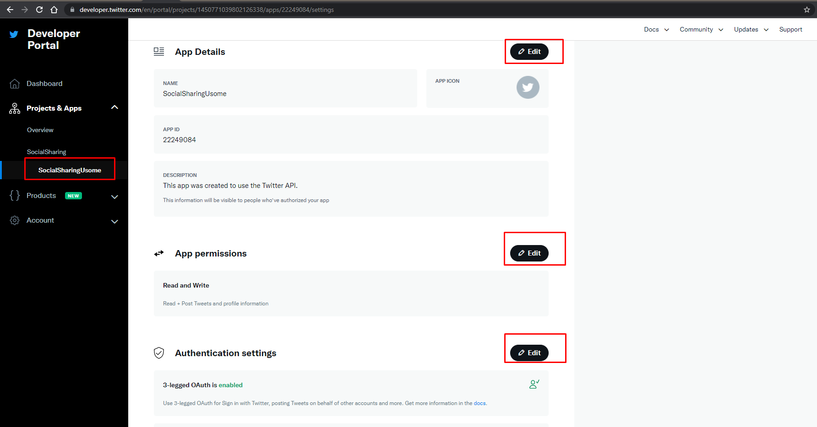

**Keys and tokens:**

Generate keys and tokens for authentication.

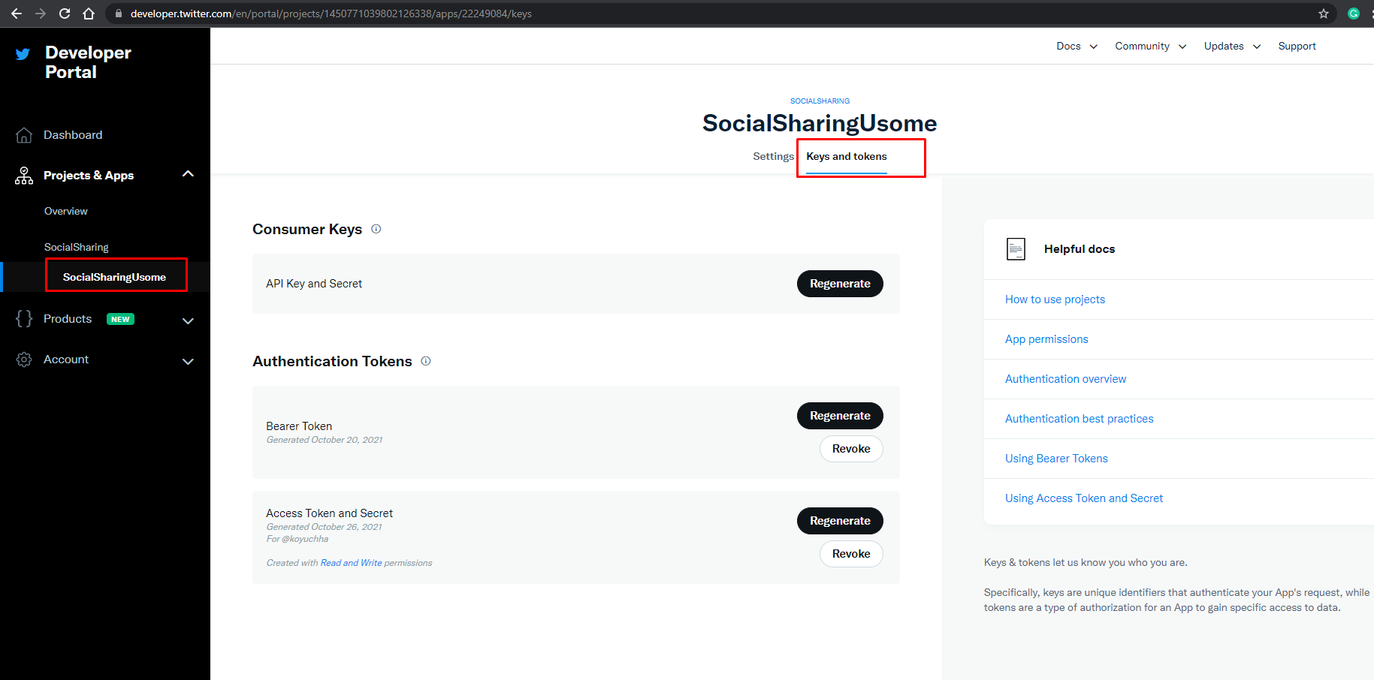

**References:**

Package/SDK : CoreTweet (<https://coretweet.github.io/)>

Twitter Doc:

<https://developer.twitter.com/en/docs/tools-and-libraries>

<https://developer.twitter.com/en/docs/twitter-for-websites/tools-and-libraries>

<https://developer.twitter.com/en/docs/authentication/oauth-1-0a/api-key-and-secret>

<https://help.xyzscripts.com/docs/social-media-auto-publish/faq/how-can-i-create-twitter-application/>

<https://github.com/CoreTweet/CoreTweet/wiki/Uploading-Image-and-Video-Howto>